A Framework for University Research Data Management
Malcolm Wolski¹, Joanna Richardson²
¹Griffith University, Brisbane, Australia, m.wolski@griffith.edu.au
²Griffith University, Brisbane, Australia, j.richardson@griffith.edu.au
Abstract
There is a pressing need for universities to improve substantially their management of research data. Good research requires good management. In recognition of this principle, many major research funders worldwide either have currently or are implementing policies that require grant holders to submit data management plans for formal approval and to manage their data in accordance with those plans. At a national level government funding and policy guidelines are placing pressure on universities to increase the accessibility of their research output. Research is a competitive field in which one of the keys to success is collaboration based on the ability to efficiently find and use quality data which is ready to be assimilated into a project—be it local, national or international—both in the immediate and in the long-term future.

In this paper the authors present a research data planning framework which conceptually follows the research lifecycle as research data moves through four main phases: data discovery and collection, cleansing and processing, analysis and computation, and finally publishing and preservation for re-use. The framework examines the cycle in terms of several key layers: governance, applications, content management, delivery services, and storage and network. This approach has been designed to develop the necessary components to have an effective and sustainable data management service for research and to ensure that it works seamlessly with current Australian national approaches.
Introduction
In a world where knowledge—and its application—is seen as a key to global competitiveness, national prosperity is viewed as underpinned by knowledge innovation (O'Brien, 2010a). Fundamental to that innovation is the dissemination of research findings. Within this context the concept of research output has been expanded to include not only the published works but also the research data and techniques associated with the research. Governments worldwide are investing in national research information infrastructures to drive national innovation. Because universities clearly have a central role in the generation of knowledge and innovation, they are major stakeholders in national innovation strategies.

This paper explores some of the major challenges faced by universities in supporting the research lifecycle, which in turn underpins discovery and innovation. It outlines an initiative by the Australian government to create a national collaborative research infrastructure as a response to these challenges, and concludes by demonstrating how one Australian university is developing a planning framework for managing research data that could be used by other universities to participate in Australia’s national collaborative infrastructure.
Research Impact, Data Management And The National Agenda
Universities in Australia—like their international counterparts—are measured in university league tables such as the Shanghai Jiao Tong, The Times, and Webometrics (Ranking Web of World Universities), where rankings have become important to stakeholders competing to attract the best students, lecturers, researchers, and the like. Similar to initiatives already rolled out in the UK and New Zealand, the Australian government is in the process of rolling out a national research evaluation initiative which is designed to provide benchmarking data for Australian universities compared with international measures. As a result government funding and policy guidelines are placing pressure on universities to increase the accessibility of their research output. The view that the commercialisation of university research has not been successful in terms of economic return has prompted the government to push for freely available, publicly-funded research findings. This is “good for industry, good for the public and good for researchers themselves, whose work will be much more widely recognised and appreciated” (Carr, 2008). Clearly the major objective is to drive substantial growth in national productivity.

In developing and supporting the research infrastructure to help achieve these objectives, it is clear that the content—and content is used here to encompass all research output—will not achieve critical mass by virtue of individual voluntary effort. It is a huge task which should not be left to non-profit organisations and individual universities, writes James Boyle, a Duke University law professor and founding board member of Creative Commons (Nelson, 2009). Instead the energy must shift to a coordinated effort between institutions, particularly universities, and the national government. This need for high-level collaboration has been echoed in a recent report to the European Commission (High Level Expert Group on Scientific Data, 2010). In addition, as O’Brien (2010b) observes, individuals are important to the outcome. The infrastructure must build “a bridge between researchers, university and national priorities”.

In Australia as part of the government’s NCRIS (National Collaborative Research Infrastructure Strategy) initiative, the Australian National Data Service (ANDS) was formed to support the “Platforms for Collaboration” capability. The service is underpinned by two fundamental concepts: (1) with the evolution of new means of data capture and storage, data has become an increasingly important component of the research endeavour, and (2) research collaboration is fundamental to the resolution of the major challenges facing humanity in the twenty-first century (Sandland, 2009).

With a view to increasing the visibility / discoverability of Australian research data collections, ANDS is building the Research Data Australia (RDA) service. It consists of web pages describing data collections produced by or relevant to Australian researchers. RDA publishes only the descriptive metadata; it is at the discretion of the custodian whether access, i.e. links, will be provided to the corresponding data. Griffith University’s involvement in several ANDS-funded projects has clarified the authors’ thinking about how to improve the overall management of research data with the objective of aligning the university with national initiatives. It has also highlighted the importance of discipline specific agendas.
Discipline Specific Challenges
In her presentation on how good data management practices can help researchers, Evans (Information Management Advisory Service (IMAS), 2010) expands what she refers to as “societal, research and other communities expectations” to include discipline-specific imperatives. Discipline specific differences will define the types of data, amount and characteristics, their specific lifecycles and usage characteristics (Winkler-Nees, 2010). Documentation and metadata requirements will differ depending on the discipline and the nature of the research. Androulkais (2009) has described how discipline-specific schemas associated with Samples, DataSets and DataFiles have been implemented as part of the ARCHER Research Repository for experimental data.

In the sciences distinctions as to the “value” of data frequently depend upon the category of data: observational, computational, experimental, and records (National Science Board, 2005). Borgman (2007), in her chapter on “Disciplines, Documents, and Data”, observes that in the sciences “data are difficult to separate from the software, equipment, documentation, and knowledge required to use them.” She contrasts the fact that whereas almost all scientific data are created by --and for-- scientific purposes, a significant portion of social scientific data consists of records created by other parties for other purposes, e.g. government and mass media. Humanities scholars, she suggests, require additional tools to assist them in “interpretation and contemplation”. Neuroth (2009) characterises the resource needs within the digital humanities as including highly heterogeneous data (digital and analogue) with complex interoperability and semantics challenges.

The importance of the impact of individual disciplines on research data management is reflected in the approach which JISC (Joint Information Systems Committee) has taken in its Managing Research Data Programme (JISC, 2010). Five projects have received funding to provide discipline-focused postgraduate training units in a range of subject areas which include health studies, performance studies, archaeology and social anthropology, geosciences, and psychological sciences. Discipline specific requirements need to be addressed in formulating a research data planning framework.
Research Lifecycle
Research data planning should follow the research cycle. Conceptually research data management encompasses all the processes and actions required to manage that data using good practice throughout the research lifecycle for current and future research purposes and users. The combination of national government pressures and the desire to increase research impact has pushed some institutions to re-examine their approach to both managing and exposing research. Until recently their scholarly output has tended to be limited to traditionally published works. More recently new publishing paradigms are emerging, with data—supporting journal articles—as the focus. The impact of this shift is to expand the role which universities can—and must—play in supporting all stages of the research lifecycle. The following diagram illustrates how the planning framework discussed in the next section of this paper aligns with the principal stages:

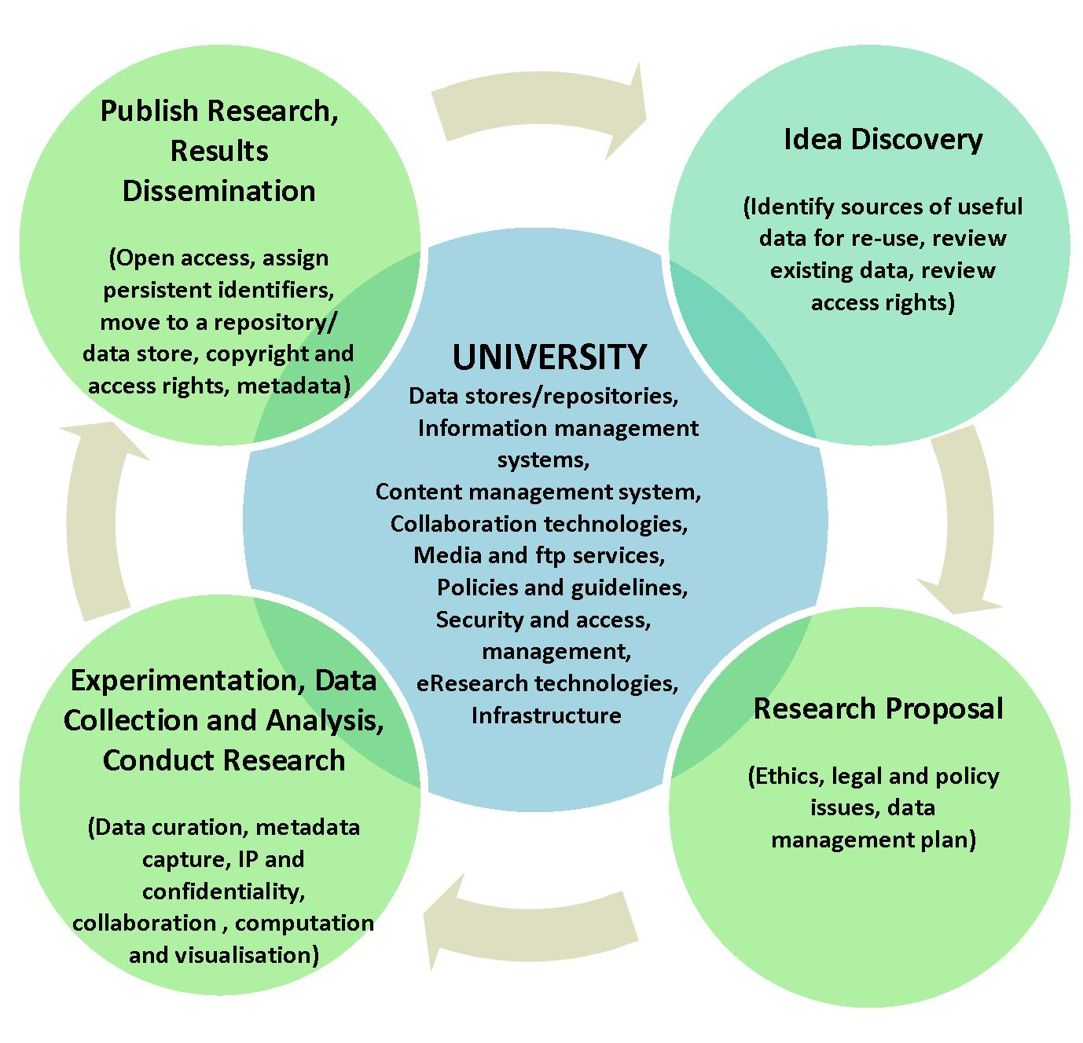
Figure 1: Principal Stages of the Research Lifecycle

Scholarly information services providers within the university context are exploring ways in which they can assist in the data collection stage, for example, as well as a much more extensive interpretation of “research outputs”.

With increased opportunity, however, comes increased complexity, as evidenced by an idealised model developed for the structural sciences, particularly chemistry (Lyon, 2009). Support for the complete research lifecycle requires research infrastructure, which can be defined as “the physical, informational and human resources essential for researchers to conduct high-quality research”(Neuroth & Blanke, 2009). It includes platforms (tools, instrumentation and facilities), resources (software and information), and human factors (support). Some of these resources may be highly dispersed and may exhibit a large variation in types and structures, particularly data. Hence the need for a well-developed planning framework.
Planning Framework
The framework in Figure 2 has been developed as a method to (a) address the need for a coordinated approach; (b) develop the necessary components to have an effective and sustainable data management service for research and (c) ensure that it works seamlessly with national approaches.

Conceptually it follows that part of the research cycle in which research data moves through the following four specific phases: data discovery and collection, cleansing and processing, analysis and computation, and finally publishing and preservation for reuse.

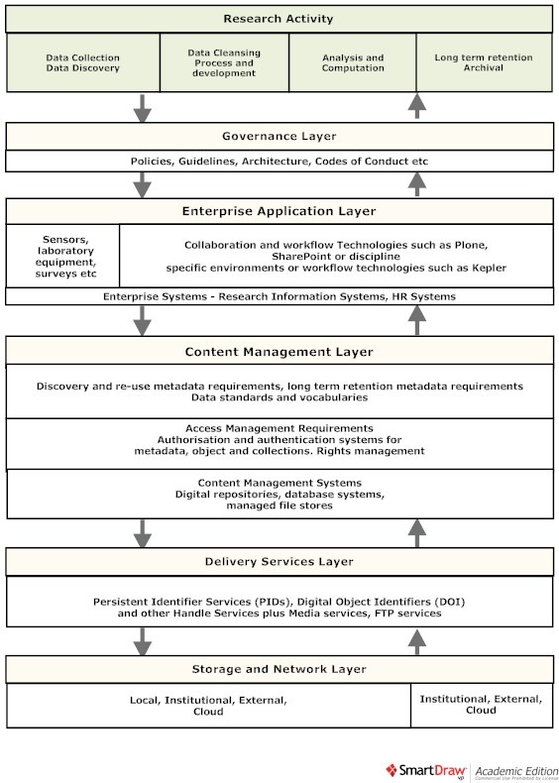

Figure 2: University Research Data Planning Framework
Governance Layer
A university’s response and the scope of activity within the university will be driven by university policy and the various instruments used to put that policy into action. The university’s response will be driven by several external drivers:
- compliance with the Australian Code for the Responsible Conduct of Research, in particular Section 2 dealing with responsibilities for the management of research data and primary materials
- trends towards research funding agencies requiring access to research data, and
- trends towards government agencies requiring open access to research data created as a result of public funds
One shortcoming of the Australian Code for the Responsible Conduct of Research is that the responsibilities of the university and the researcher and the department are seen as quite separate. This does not reflect the practical dependencies on good practice earlier on in the research process to deliver cost-effective long-term data management solutions.

Cost-effective management of data over the term of its life relies heavily on all parties undertaking their responsibilities, using common standards and processes and in some cases standard technology. Beagrie et al. (Beagrie, 2010; Beagrie, Lavoie, & Woollard, 2009) have estimated that the cost distribution for long term preservation is : Access (c 31%), Outreach/Acquisition/Ingest (c. 55%) and Archiving (c. 15%). They also have noted that staff costs are a significant proportion of final costs and are fixed due to the minimal viable staff needed and the skill sets required to maintain services. A coordinated approach to data management and an early intervention from the university from data collection onwards would help to reduce and manage the acquisition and ingest costs and improve the quality of the research data preserved.

To achieve a coordinated approach the university will need to review its policies, roles and responsibilities within organization units and address enterprise architectural issues. The following discussion provides examples of possible governance issues to be addressed.

Policy development will need to address a number of areas including:
- The definition of research activity, research data and research outputs
- The university’s support for open access publishing and support for Creative Commons licensing
- Policy on where researchers are required to store research outputs. This will need to address:
  - internal storage and external/cloud services, e.g. the Australian Research Collaboration Service (ARCS) Data Fabric
  - the difference between storing descriptive metadata and a data store location versus actual stored research data
  - what goes in what repository – journal articles in the standard research publication repository versus a research data store & how they link
- What are the terms and conditions of storing data in enterprise repositories, e.g. rights of withdrawal, ethics clearance, IP / copyright clearance
- What needs to go into strategic, operational and performance plans to implement policy
- Faculty and Centre policies on managing laboratory data
The five types of policy instruments identified by Althaus, Bridgman, & Davis (2007, p. 89) are applicable in implementing research data management policies. It is important to consider these when developing policies, if there is to be an effective implementation of those policies. This will also have the effect of gaining the understanding of the impact of the new policies. The instruments available are:
- Advocacy – what is the role for key positions (e.g. Deans) and organisational units (e.g. Library, IT) in educating or persuading researchers, disseminating information (e.g. data management planning guidelines, the minimum standards for describing data and what is the minimum set of documents to be retained with research data)
- Networks - what are the key networks impacted, e.g. faculties, research centres, discipline groups. Not all these networks will be contained within the university, so policies will need to take this into account
- Funding – who will be providing resources to implement the various policy objectives. Will financial incentives drive a change in behaviour e.g. a financial incentive added to each successful grant to preserve data or one-off grants to develop laboratory management data management systems
- Direct action – organizational units such as IT or the library delivering new services to encourage a change in behaviour or to provide the resources necessary to lower the cost of adopting new practices
- Regulatory - While external agencies may mandate their own requirements, a university may consider imposing its own processes to force change, e.g. requiring data management plans for each research grant, formally adopting standards such as ISO2146

A key part of developing and implementing university research data management policies is to have a clear understanding of roles and responsibilities of key groups within the university and, in some instances, external to the university. This will include:
- the various organizational units involved in: collecting data used for government reporting versus collecting information on research data required for publishing and who maintains the links between the published article and the research data
- the role of discipline groups with specific data requirements
- where research activity is recorded in system/s and who is the owner of those systems and their obligations in making data publicly available (e.g. information on projects, people, and research outputs is held within which system)
- who is responsible for providing and managing repository solutions and for what types of research output
- who decides what data is to be retained and for how long
- who is responsible for providing / funding the infrastructure
- who is responsible for preparing the data for long-term preservation and accessibility / re-use
Policies will also need to take into account the federated or sometimes even ad hoc nature of preserving research data. While universities are developing solutions, the federal government and other key groups are also developing large archives to preserve research output. Policies will need to address the question of when to capture and preserve data within the institution and when to outsource it (e.g. a federal archive like ASSDA). If outsourced, how does a university have it tagged as their university output or find it in university discovery tools.

Finally there are a number of issues to be addressed through a well planned enterprise IT and information architecture. These include:
- addressing the need to migrate descriptive and other metadata between enterprise applications, e.g. from collaboration environments (e.g. SharePoint, Confluence) or systems capturing data migrating to long term repositories
- developing enterprise solutions for persistent identifiers for accessibility of research output anywhere inside the enterprise and in “cloud” or national discipline/project based repositories
- an enterprise discovery layer for all research activity at the university – where do you find this information? The library, institutional repository and/or corporate web site search facilities?
- mapping the content management systems to a storage infrastructure which will need to include cloud-based storage services
- what is the true source of key data (e.g. staff ID, project descriptions) and more importantly which systems retain the information about relationships between that data (e.g. to map published articles to research data relevant to that article)
- how to manage multiple identifiers, e.g. for persons allocated a staff ID, Trove ID, Australian Research Council ID
- how to provide citation and other statistical services for not only publications but also data collections and other objects identifying research activity

An enterprise wide response to improving management of research data will impact current enterprise systems and may require new systems to be developed to capture key data currently missing (e.g. relationship data required to meet the ISO2146 standard).
Enterprise Application Layer
One often neglected application suite within the university enterprise systems suite of products is a standard suite of applications to collect research data, e.g. online surveys tools, laboratory workflow technologies, electronic lab books, which can be discipline specific. Similarly online collaboration tends to be a mixture of solutions utilising (a) enterprise solutions (e.g. SharePoint, Lotus QuickPlace) or (b) more project specific solutions such as Confluence, customised environments utilising commonly used corporate management systems (e.g. Drupal, Joomla, Plone) or (c) public tools such as Google Groups.

Finding and developing these solutions are typically seen as part of a research project’s responsibilities. However this approach is neither cost effective nor compatible with developing enterprise solutions where managing and preserving research data is the main objective. This is not to say that these solutions are not the best options but requirements for such systems may be quite different if one were to include the need to capture metadata required for long term preservation, storage life cycle management or data necessary for later discovery and access (e.g. standard metadata and descriptions, cross reference information to other related information such as university allocated research project ID). Data retained in solutions developed as standalone systems to meet project objectives may require considerable effort at the end of the project to make it ready for long term preservation.

The second generally neglected suite of applications is in relation to long term preservation. Existing enterprise applications are integral as well to this suite of applications such as research administration systems, human resources systems, identity management systems, and ethics clearance systems.

Another consideration is to identify ways to capture metadata as close as possible to the source of data capture or creation rather than the less effective method of trying to add it later. This may involve developing systems and methods to assist researchers to develop methods of adding metadata during data collection early in the research process, e.g. additional metadata added to survey files or control files to accompany data sets.

On a final note, the trend towards using outsourced and cloud / hosted services will complicate the issue further. On the one hand is the requirement to align University services through federal initiatives (e.g. ARCS, ANDS, AAF) and on the other, services offered at very competitive rates by a whole host of international service providers.
Content Management Layer
The content management layer is separated from the application layer. In some applications this comes as an integrated product. Most universities have developed repositories for publications to support government reporting requirements such as HERDC (Higher Education Research Data Collection) and ERA (Excellence in Research for Australia). However not all of these are seen as enterprise applications by their respective IT departments. Some universities have developed applications to manage grey materials (e.g. reports, plans etc) and some have developed applications to manage research data for projects or specific centres. Very few universities have an integrated suite of enterprise applications that can manage all research outputs over time and cross reference materials between each system.

The purpose of planning for content management as a separate layer is based on a number of factors, which include:
- developing an enterprise view of repositories: what they manage and the relationships between objects in those repositories (e.g. published journal articles linked to research data in another repository)
- identifying one authoritative source for specific data and specific objects (e.g. journal article) which may need to be delivered to various applications (e.g. websites, profile systems, ARDC)
- developing discovery tools to access and export descriptive metadata and to develop enterprise discovery mechanisms
- developing minimum standards for metadata to facilitate discovery and encourage the re-use of data
- developing a consistent method to deal with long term lifecycle management issue (e.g. age reports, project data reports)
- promoting consistent data standards especially around collection management over the long term (e.g. ISO2146)
- retaining information about objects stored in the enterprise storage networks that were not captured in any enterprise applications or information about objects stored offsite (e.g. relationships between a project and published articles, descriptions of data stored in a national repository)
- managing authorisation and access as close as possible to the object to be able to make it consistently accessible to any number of applications and discovery tools

Undoubtedly one of the greatest challenges for researchers is the effort to not only locate their data but also to format it for discovery and potential re-use. At a meeting in Rome in 2009 mouse researchers discussed the impact caused by new technologies which generate very large datasets and novel biological materials. In terms of linking their data to publications, the meeting participants concluded that “the largest part of the data underlying publications is archived on journals’ ‘supplemental information’ sites or authors’ own sites. These data are often formatted in a non-standard way, not readily searchable, and in the long term not guaranteed to persist” (Schofield et al., 2009).

This highlights the need for a minimum set of clearly defined data standards, e.g. formats and metadata. Compounding the problem is that even if researchers are prepared to allocate resources to enter the required metadata into content management systems, it is unquestionably a lot of work. Mechanisms need to be developed to facilitate the process of adding data to the relevant systems.
Delivery Services Layer
The content management layer is separated from the delivery services layer in this framework. In some content management system products these may be integrated. The purpose of looking at delivery services separately is that these can be provided quite independently from the content and storage, and they may be outsourced. Two groups of services are mentioned: those that provide persistent identifiers to locate objects and those that deliver objects depending on some specific characteristics, e.g. file size, file format etc.

The methods of applying persistent identifiers are crucial in an environment where objects are to be made accessible from multiple access points especially if those access parts are unknown or uncontrolled (e.g. a DOI in a published article, a link on a website), where the object is stored outside the university, where there is an order of steps required to apply identifiers (e.g. a DOI created for data to be inserted into a journal article for publication), or where the identifiers are not just for objects but also for staff or projects profiles.

As a wide variety of objects become stored in managed repositories, there will be a need to ensure there are methods for delivering those objects in the appropriate environment. Many of these will default to using the local application software but some will need intervention. For example in an archive repository where large files are stored in tape it may take a while to retrieve the file – in which case a drop box, an enterprise ftp service or enterprise streaming service may be appropriate. In either case there may be opportunities to outsource some of these services such as those provided by ARCS (Australian Research Collaboration Service).

Storage and Network Layer
The storage and network layer needs to be planned separately especially if the goal is to have an integrated storage layer that includes cloud or national storage services. In some instances even local storage may be a viable option (e.g. laboratories). Any storage service needs to start from the equivalent consumer offering (at the time of writing about $70 per TB), describing the differences between each storage type offered.
To develop a storage service model for an integrated service where the researcher need not worry about where the data is to be held, there must be an effective method to capture the researcher’s requirements and any constraints around the data such as privacy, ethics or access constraints. These requirements will need to be mapped to the appropriate solution and cost. The faculty or discipline group has a role to play in designing these solutions. Underneath this service offering, technology lifecycle solutions need to be incorporated into the overall solution to ensure the most effective storage is used, based on some policy decisions such as age, file type, privacy or archival classification schemes. Finally any movement of data needs to take into account load on the network. For specific research activities special solutions may need to be developed both internal to the university (e.g. NAS devices in laboratories) and external to the university.
Conclusion
Universities need to improve the management of their research data, which will benefit the researcher and the university in the medium to long term. To achieve the best solution possible, universities need to break the problem down into several layers: governance, applications, content management, delivery services, and storage and network. The proposed framework provides opportunities to align the university with national initiatives and to integrate hosted and outsourced services into the overall solution, thereby meeting the objective of providing a cost effective, consistent and seamless service to the research community.
It will also ensure that both the university and the researcher achieve both short-term and long-term goals: manage their research outputs according to good practice; comply with policy guidelines and legislation no matter where they are stored; and provide assurance that access and discovery are managed.
References

